C++ TEST SUBMISSION : PRACHI SHARMA

2022A1R179

LeetCode Problem : Valid Parentheses

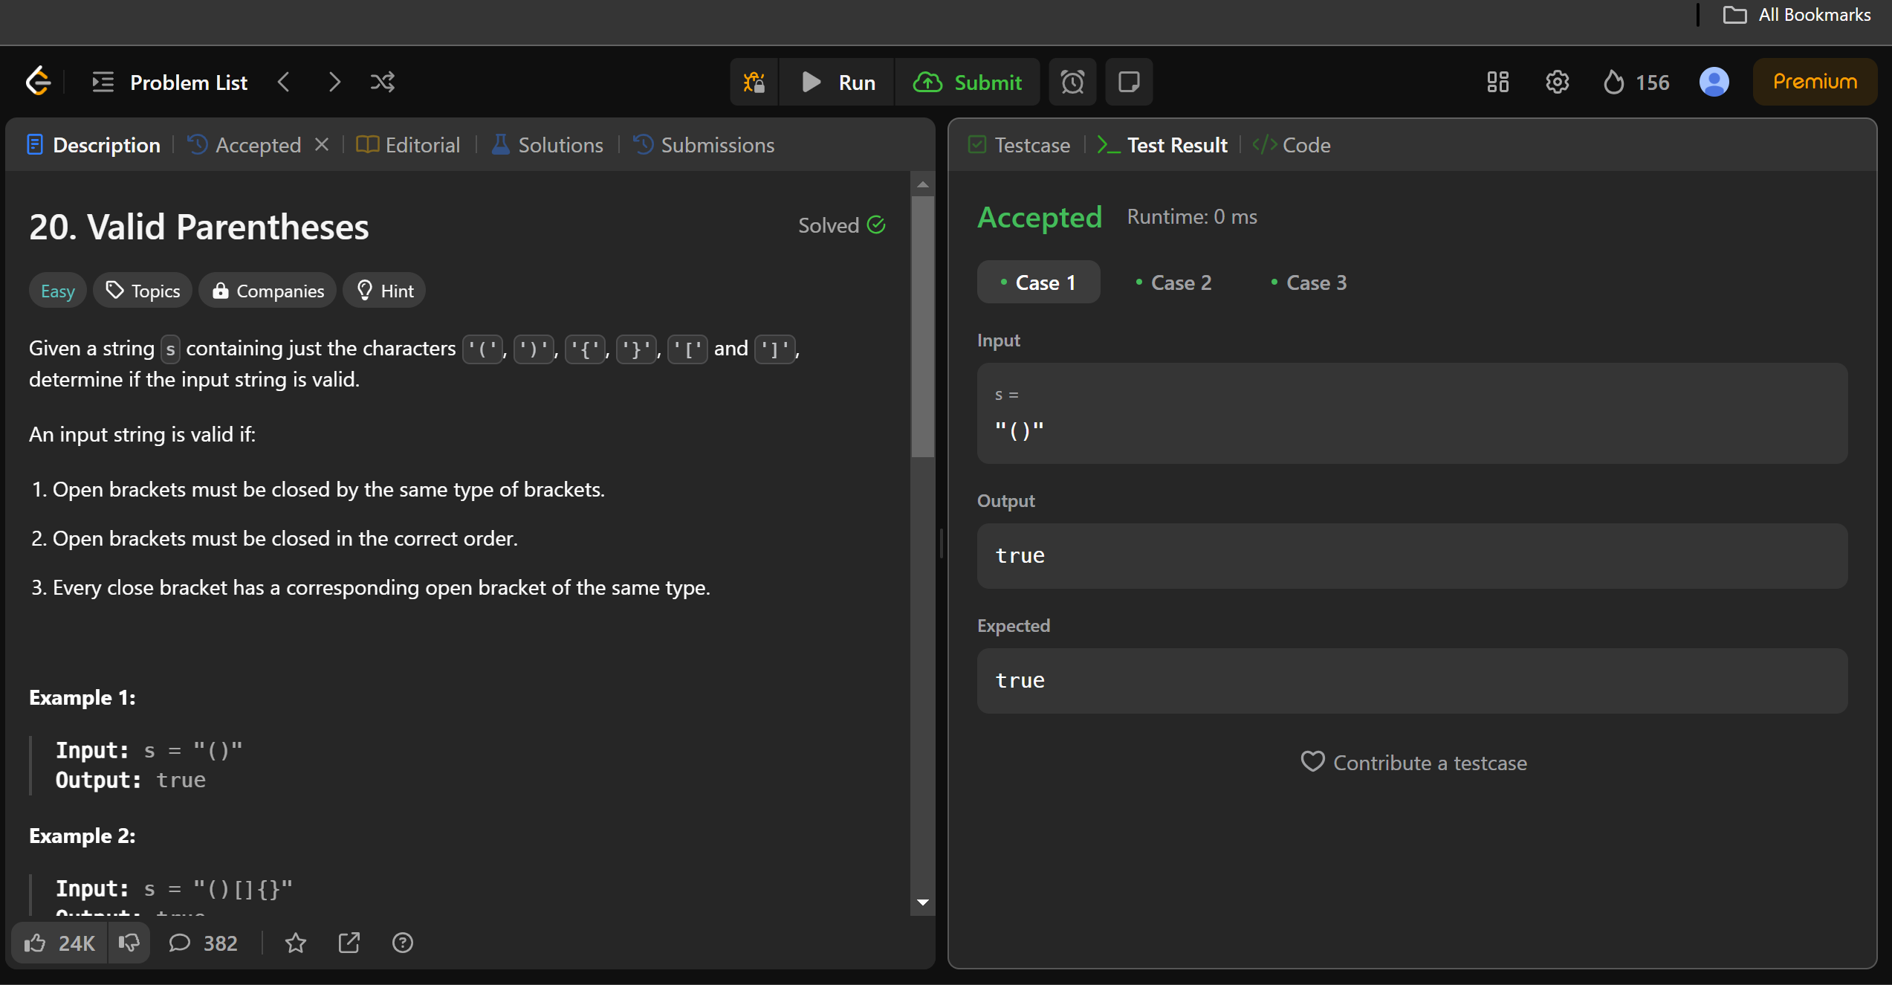

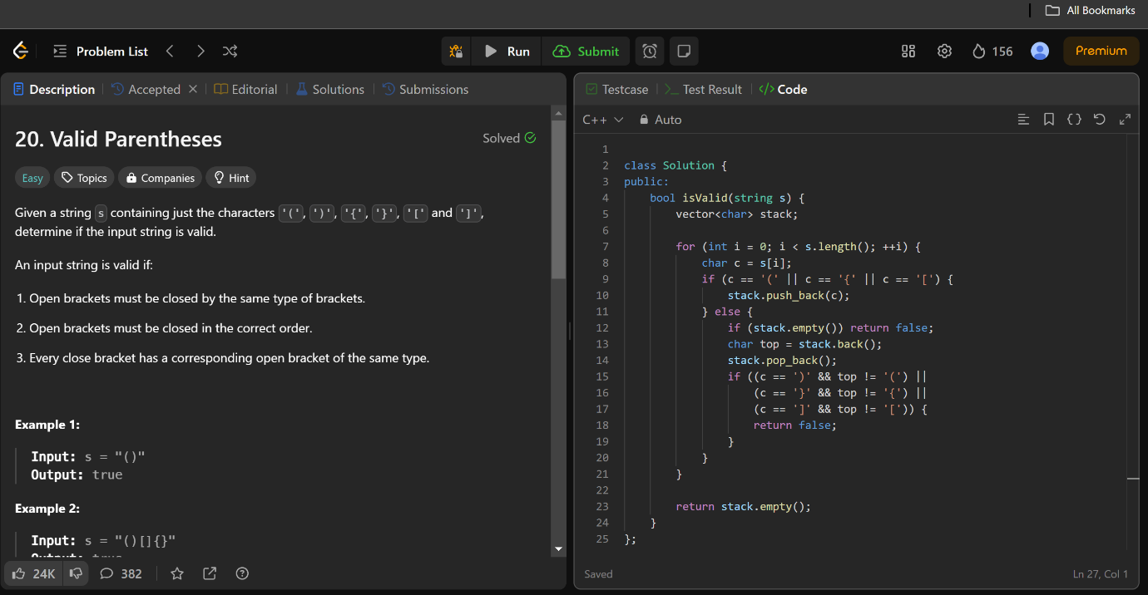

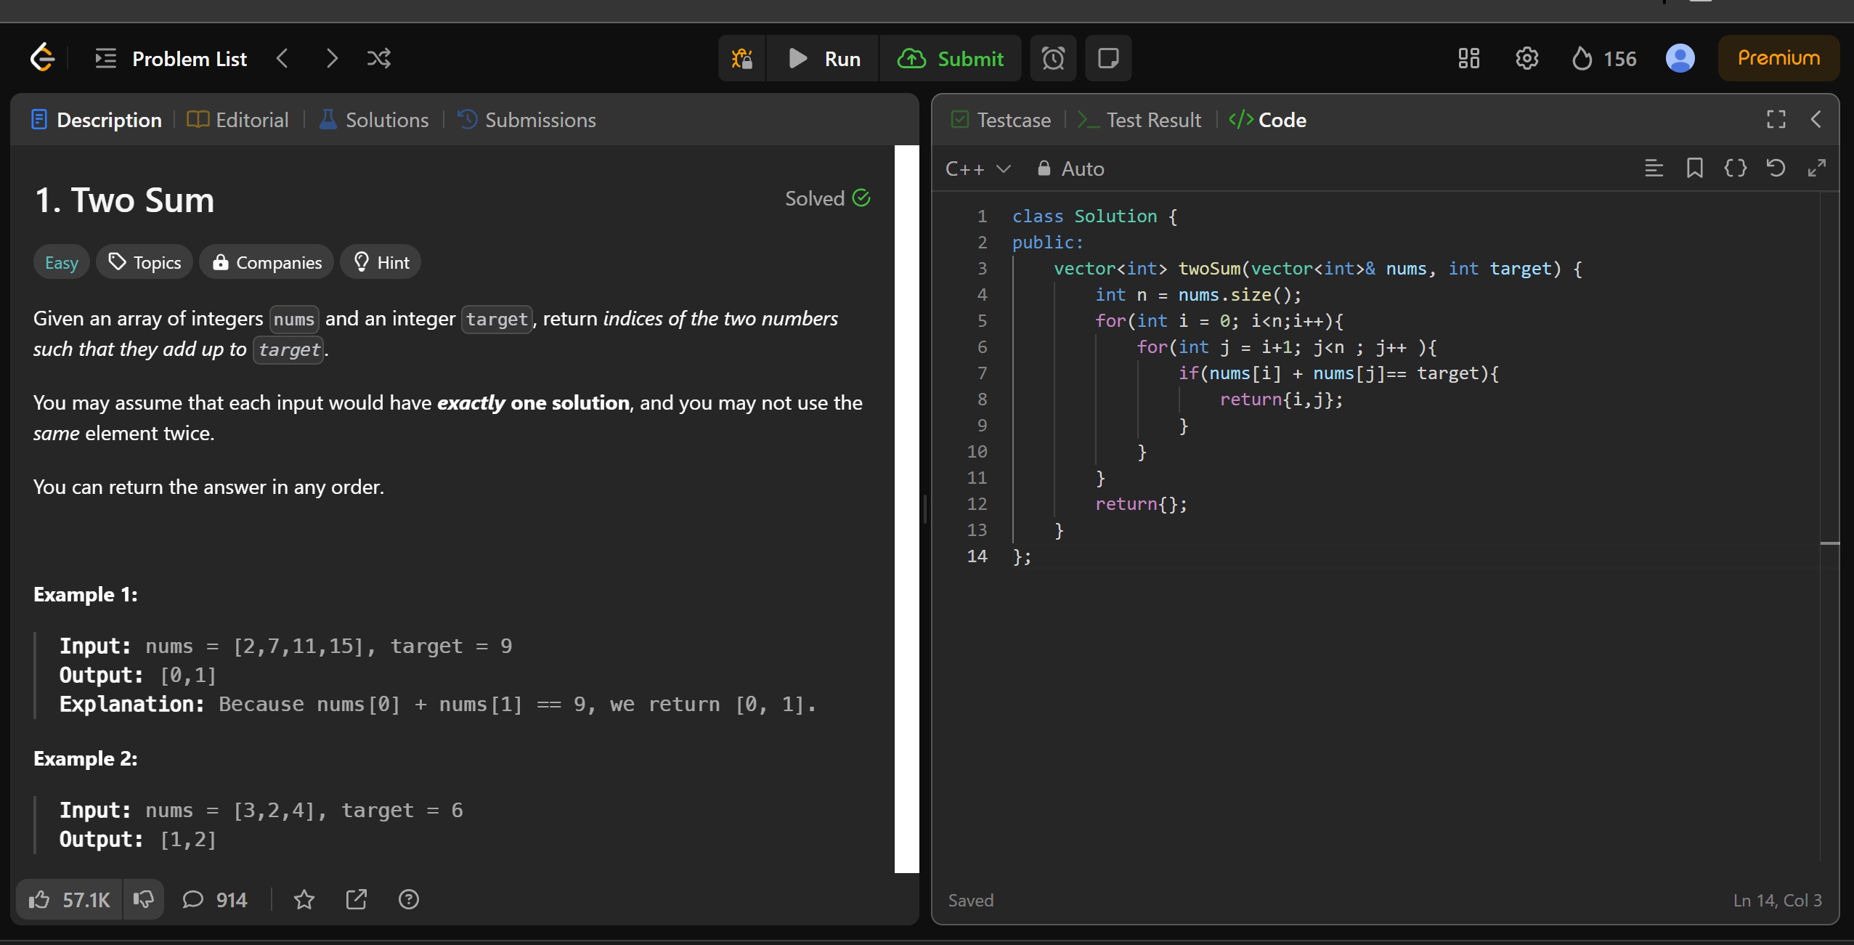

Leetcode Problem 2: Two Sum

